

**Group Members:**

1. SH M SHARJEEL – BSE173090
2. USMAN MAZHAR – BSE173095
3. ASIM FAROOQ – BSE173074
4. HAMZA AFZAAL – BSE173131

**Assignment #** 4 +5

**Section:** S1

**Submitted To:** Sir Samir Ubaid

Table of Contents

CASE STUDY: 3

MCDC: 3

1.1 Decision Statements 3

2.1 Implementation: 3

1.2 Decision Statement 4

2.2 Implementation: 4

1.3 Decision Statement 5

2.3 Implementation: 5

Path Prediction Expression 7

Prediction 1 7

Path 7

Expression 7

Prediction 2 7

Path 7

Expression 7

Prediction 3 7

Path 7

Expression 7

Prediction 4 7

Path 7

Expression 7

Test Oracle 8

# CASE STUDY:

The government has decided to change policy for the driving license. Now in order to apply you have to meet the criteria and also have to pass 2 exams. The exam will be held on same day and the attendee have to pass both the tests in order to receive the license otherwise, he/she will have to try again when eligible or with better preparation.

Following are the conditions that should be meet.

1. Test1 = Age>=18 and Verbal test score >80 and Theory test score >86
2. Test2 = Parking score >=80 and Driving skills score > 80 and Breaking Traffic law score < 15.
3. Now the both tests should be passed or to be accurate both have to be true in order to get a license otherwise not.

# MCDC:

## 1.1 Decision Statements

INPUT OUTPUT

|  |  |  |  |
| --- | --- | --- | --- |
| Age | Verbal Test Score | Theory Test score | age>=18 && verbaltestscore>80 && theorytestscore>86 |
| T | T | T | T |
| T | T | F | F |
| T | F | T | F |
| T | F | F | F |
| F | T | T | F |
| F | T | F | F |
| F | F | T | F |
| F | F | F | F |

# 2.1 Implementation:

INPUT OUTPUT

|  |  |  |  |
| --- | --- | --- | --- |
| Age | Verbal Test Score | Theory Test Score | Result |
| 18 | 85 | 90 | T |
| 19 | 85 | 20 | F |
| 20 | 70 | 91 | F |
| 20 | 70 | 50 | F |
| 10 | 90 | 95 | F |
| 10 | 90 | 40 | F |
| 15 | 60 | 95 | F |
| 14 | 60 | 76 | F |

## 1.2 Decision Statement

INPUT OUTPUT

|  |  |  |  |
| --- | --- | --- | --- |
| Parking Score | Driving Skill Score | Breaking Traffic law Score | Parkingscore>=80 && drivingskillscore>80 && breakingtrafficlawscore<15 |
| T | T | T | T |
| T | T | F | F |
| T | F | T | F |
| T | F | F | F |
| F | T | T | F |
| F | T | F | F |
| F | F | T | F |
| F | F | F | F |

## 2.2 Implementation:

INPUT OUTPUT

|  |  |  |  |
| --- | --- | --- | --- |
| Parking Score | Driving Skill Score | Breaking Traffic Law | Result |
| 80 | 81 | 10 | T |
| 85 | 70 | 20 | F |
| 90 | 85 | 8 | F |
| 90 | 70 | 30 | F |
| 70 | 90 | 2 | F |
| 60 | 40 | 40 | F |
| 50 | 90 | 5 | F |
| 40 | 20 | 80 | F |

## 1.3 Decision Statement

INPUT OUTPUT

|  |  |  |
| --- | --- | --- |
| TEST 1 | TEST 2 | RESULT |
| T | T | T |
| T | F | F |
| F | T | F |
| F | F | F |

## 2.3 Implementation:

In this case both the Test1 and Test2 have bool values that’s why they are given T or F values.

INPUT OUTPUT

|  |  |  |
| --- | --- | --- |
| TEST 1 | TEST 2 | RESULT |
| T | T | T |
| T | F | F |
| F | T | F |
| F | F | F |

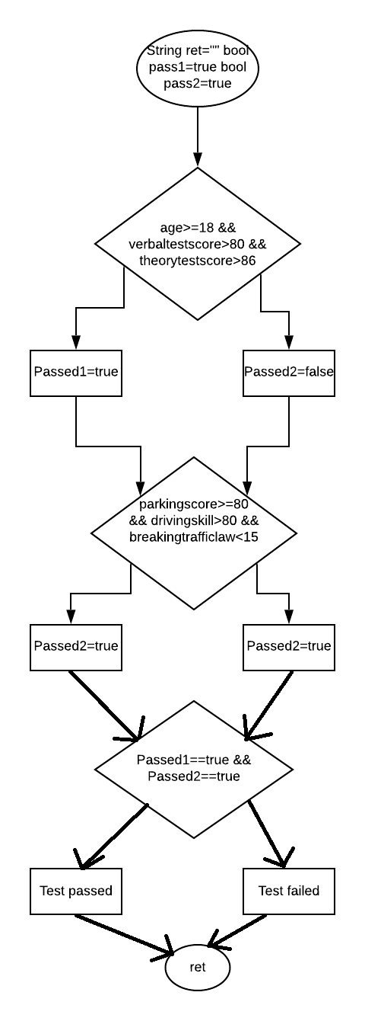

# Path Prediction Expression

## Prediction 1

### Path

1 -> 2 -> 3 -> 5 -> 6 -> 8 -> 9 ->11

### Expression

{age>=18 && verbeltest>80 && theorytest>86, parkingscore>=80 && drivingskillsscore>80 && breakingtrafficlawsscore<15, passed1==true && passed2==true}

## Prediction 2

### Path

1 -> 2 -> 3 -> 5 -> 7 -> 8 -> 10 ->11

### Expression

{age>=18 && verbeltest>80 && theorytest>86, parkingscore<=80 && drivingskillsscore>80 && breakingtrafficlawsscore<15, passed1==true && passed2==false}

## Prediction 3

### Path

1 -> 2 -> 4 -> 5 -> 6 -> 8 -> 10 ->11

### Expression

{age>=18 && verbeltest<80 && theorytest>86, parkingscore>=80 && drivingskillsscore>80 && breakingtrafficlawsscore<15, passed1==false && passed2==true}

## Prediction 4

### Path

1 → 2 → 4 → 5 → 7 → 8 → 10 → 11

### Expression

{age>=18 && verbeltest<80 && theorytest>86, parkingscore>=80 && drivingskillsscore<80 && breakingtrafficlawsscore<15, passed1==false && passed2==false}

# Test Oracle

Expect Outcome 1: “You have passed the TEST"  
Expect Outcome 2: "TestFailed."

|  |  |  |  |  |  |  |  |  |
| --- | --- | --- | --- | --- | --- | --- | --- | --- |
| **Path** | **Inputs** | | | | | | **Actual**  **Outcome** | **Expected Outcome** |
| **Age** | **Verbeltest** | **Theorytest** | **parkingscore** | **drivingsscore** | **breakingtrafficclaws** |
| 1 -> 2 -> 3 -> 5 -> 6 -> 8 -> 9 ->11 | 18 | 85 |  | 13 | 25 | 50 | You have passed the TEST | You have passed the TEST |
| 1 -> 2 -> 3 -> 5 -> 7 -> 8 -> 10 ->11 | 10 | 2 | 12 | 15 | 20 | 30 | TestFailed | TestFailed |
| 1 -> 2 -> 4 -> 5 -> 6 -> 8 -> 10 ->11 | 18 | 4 | 10 | 14 | 0 | 20 | TestFailed | TestFailed |
| 1 → 2 → 4 → 5 → 7 → 8 → 10 → 11 | 9 | 0 | 10 | 16 | 0 | 30 | TestFailed | TestFailed |